1. Code examples on the AI fairness website <https://aif360.mybluemix.net/>
   1. [AI Fairness Github](https://github.com/Trusted-AI/AIF360/tree/master/aif360/aif360-r)
2. First work with the Reject option based classification, looks most promising
   1. Watch for a reduction in accuracy
   2. [Code to add Reject Option Classification component](https://github.com/Trusted-AI/AIF360/blob/master/aif360/aif360-r/man/reject_option_classification.Rd)
   3. [Code for Post Processing Reject Option Classification](https://github.com/Trusted-AI/AIF360/blob/master/aif360/aif360-r/R/postprocessing_reject_option_classification.R)
3. Repeat step 2 with the reweighing
   1. Is this less effective being pre-processing?
   2. [Code to test Reweighing component](https://github.com/Trusted-AI/AIF360/blob/master/aif360/aif360-r/tests/testthat/test-reweighing.R)
   3. [Code to add Reweighing component](https://github.com/Trusted-AI/AIF360/blob/master/aif360/aif360-r/man/reweighing.Rd)
   4. [Code for Preprocessing Reweighing](https://github.com/Trusted-AI/AIF360/blob/master/aif360/aif360-r/R/preprocessing_reweighing.R)
4. Communicate back any problems
   1. Might have to research more possible strategies other than in AI fairness

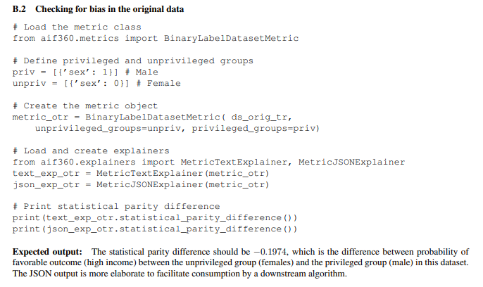

Link to read more: <https://arxiv.org/abs/1810.01943>

